**Organization Chart for CC Project**

Prepared by: Kyle Tran – Project manager of CC Project

Date: April 27th 2019

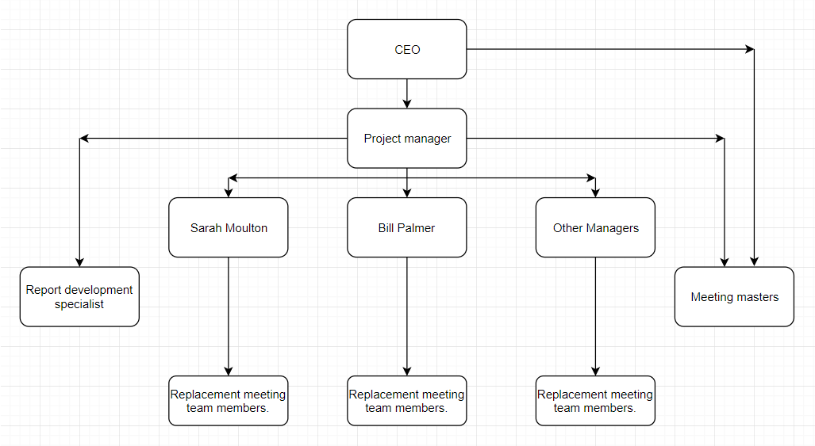

In the CC Project or Communication change project, there are four layers of position that will play crucial parts. The four layers include CEO, Project Manager of CC Project, other managers of Part Unlimited departments and the lower level layer, who will take command from managers.

The first layer or the highest layer is Parts Unlimited CEO, Steve Master. The role of Steve Master is confirming every details of CC Project before it is launched. The second role of Steve Master is receiving urgent notice from the project manager and the meeting masters when it is necessary.

The second layer is the project manager of CC Project. The project manager has the responsibility to keep the project on track, to make sure the whole process follows all the milestones and goals that mentioned in the deliverables. The project manager will take command and report directly to the CEO in urgent situation to make changes. Project managers will play another important part in helping third-party specialists hold training sessions and respond to confusion as well as requests from the department managers, especially from Sarah Moulton and Bill Palmer because those two departments share the biggest communication in Parts Unlimited. Project manager also do check, guiding and give command directly to Report development specialists and meeting masters.

Report development specialist and meeting masters will take command directly from project manager to make sure everything is on track. Report development specialists are hired from a third party and meeting masters will be choose from Parts Unlimited to do the training with new reporting system. Report development specialists will develop the new report system and help project manager hold the trainings program. Report development specialists also have responsibility to support Meeting masters get used to the new reporting system.

The third layer is all the managers from different departments in Parts Unlimited. The managers will have responsibility to train with new meeting and reporting system. They also must submit respond and request for the new system to the project manager. Department managers will have to pick 3 team members from their teams for another training of replacement meeting. Those team members will have to practice in real system in the beginning of week 3 to the middle of week 4.

The last layers include all the picked team members from each team, meeting master and the specialists. Although the third-party specialist and meeting master do not take command from the department managers, they do not have any lower level layer. As a result, they are considered as the last layer in CC Project.